University of California, Davis

**Take Home Project 1**

Question 2: Diet & Weight Loss

Ana Boeriu & Julia Tien

STA 106

Dr. Erin Melcon

February 9, 2018

**I. Introduction**

The goal of this project is to ultimately find out which diet is most effective in helping people lose weight using this sample of 76 people. We will perform different statistical measures such as exploratory data analysis, hypothesis tests, diagnostics, and form pairwise confidence intervals to analyze the data and reach conclusions. The approach we are going to take is using ANOVA which is typically the method used when testing differences between means of groups. More specifically we are using the Group Means Model. In this case, there is the categorical explanatory (X) variable with three diets (A, B, C) and the numerical response variable (Y) which is the difference in pounds. A positive number suggests a loss in weight while a negative amount means there was an increase in weight. Dieticians or anyone in the general population who is trying to lose weight may be interested in this outcome as it will help them be more effective in determining what lifestyle changes may need to be made.

**II. Summary** (This should include things like plots (histograms, box plots) including the interpretation of the plots, and summary values such as sample means and standard deviations. You should have an idea about the trend of the data from this section.)

1. **Summary of Data:**

|  |  |  |  |
| --- | --- | --- | --- |
| Diet | Number of people | Mean | Standard deviation |
| A | 24 | 3.300 | 2.240148 |
| B | 25 | 3.2680 | 2.464535 |
| C | 27 | 5.2333 | 2.247734 |

Weight Loss Summary Statistics:

|  |  |  |  |
| --- | --- | --- | --- |
| Min: | -2.100 | Mean | 3.976 |
| 1st Quartile | 2.35 | 3rd Quartile | 5.650 |
| Median | 3.700 | Max | 9.20 |
| Standard Deviation | 2.473156 |  |  |

1. **Box Plot**

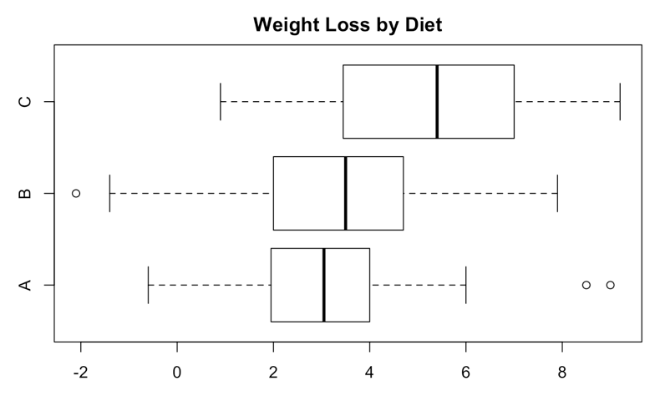

This boxplot shows that Diet C had greatest average weight loss as well as highest minimum weight loss. Diet B had the greatest spread of data while Diet A had the lowest mean and maximum.

1. **Histogram**

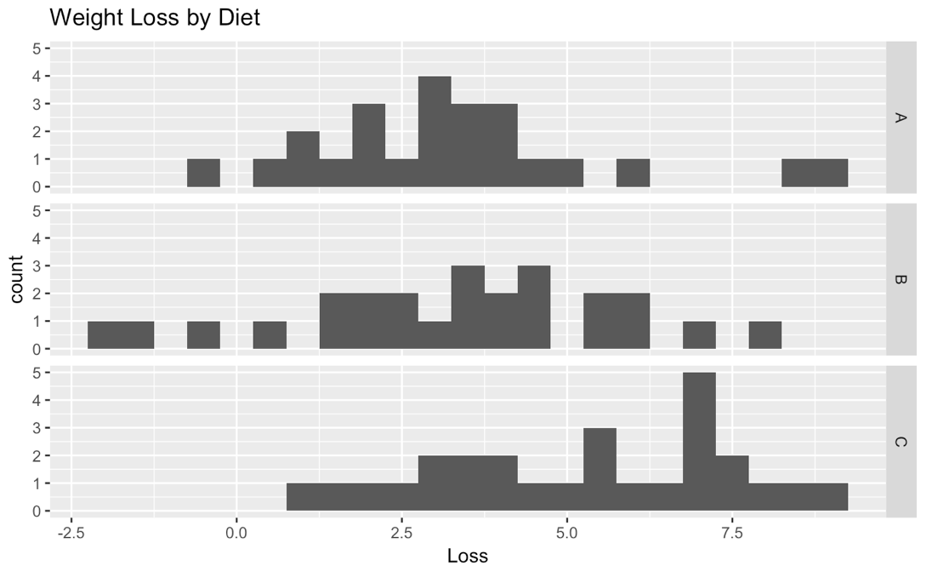

This histogram shows that none of the weight loss by diet groups are normally distributed although Diet A could be considered closest to it. Diet B seems to have the greatest spread of data.

The trends seen in this section are that Diet C seems to have the greatest weight loss when compared to Diets A and B.

**III. Diagnostics**

Diagnostics are performed to evaluate how well the data meets the assumptions for ANOVA. The assumptions of ANOVA are that the data is randomly sampled and independent, the different diet groups are independent and the errors are normally distributed with a mean of 0 and a variance of 𝜎2. In this section we will first look for outliers and then use diagnostics to test these assumptions, specifically for normality and constant variance in the errors. We will be using a 5% significance level (alpha of .050) as that is conservative yet not too strict.

1. **Outliers**

While the boxplot from Section IIB may show that there are three outliers with Diet A, when completing the semi-studentized and standardized residual analyses we found that there are no outliers so we have not removed any data points.

1. **Testing for Normality**
2. **QQ Plot**

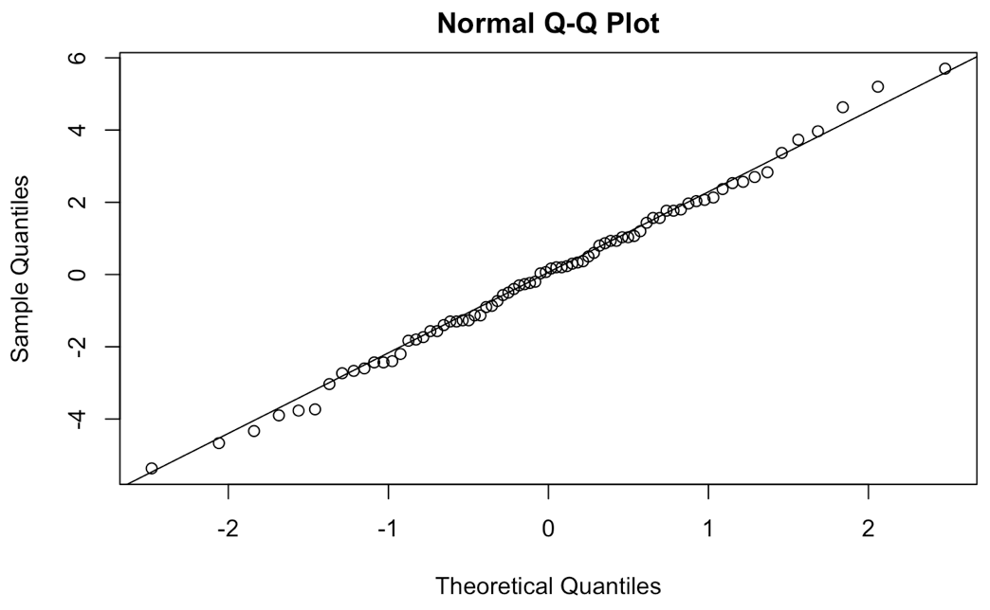

This QQ plot shows most of the data falls on the X=Y which could signify normal errors, however this is a subjective judgement.

1. **Shapiro-Wilks**

$Ho:Data is normal Ha:Data is non-normal$

|  |
| --- |
| P-value = 0.9921 |

Because our p-value is greater than the alpha of 0.05, there is evidence to fail to reject the null and we conclude that our data is approximately normally distributed.

1. **Testing for Constant Variance**
2. **Errors vs. Groups**

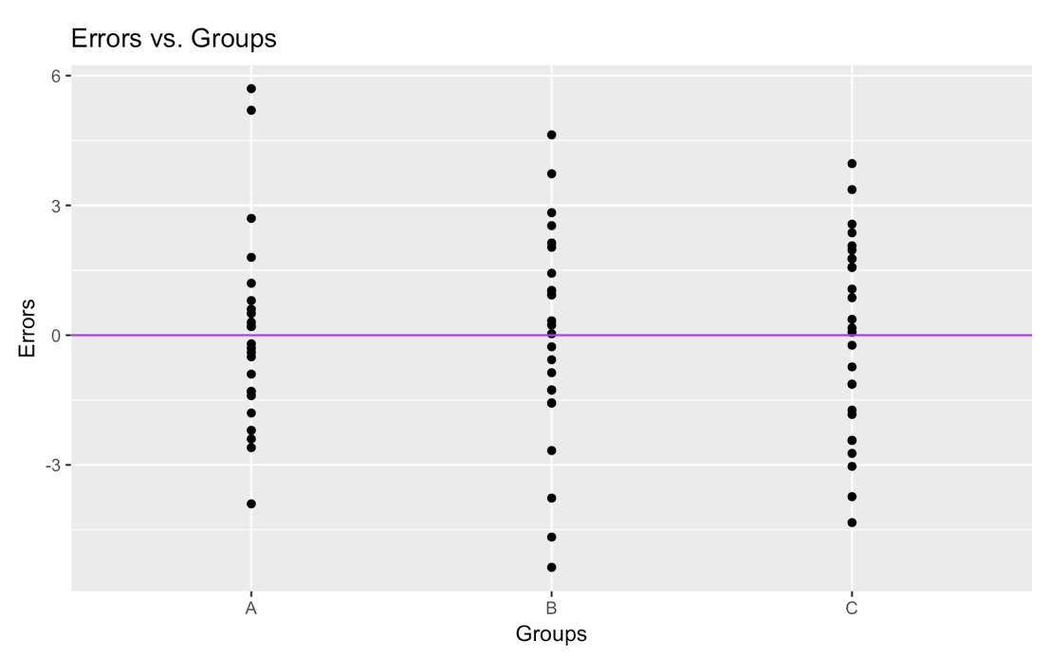

This plot shows that there does seem to be constant variance in the errors between groups.

1. **Brown-Forsythe Test**

$$Ho:Residuals have equal variance Ha:Residuals do not have equal variance$$

|  |
| --- |
| P-value: 0.694648 |

Because this p-value is greater than an alpha value of 0.05, we fail to reject the null hypothesis and there is evidence to conclude there is equal variance.

1. **Conclusion**

As seen in the plots and performing statistical tests, the data is approximately normal and has constant variance so this assumption for ANOVA is met and we can proceed to use ANOVA with the data and make inferences.

**IV. Analysis & Interpretation**

1. **Model Fit**

Group Means Model: Y=μi+εij

For μi the estimate for overall sample mean is 3.976. The individual sample means are estimated to be: A= 3.3 B= 3.268 C  = 5.233 as seen from the table in part IIA. The estimate of the variance of the errors would be MSE which is 5.377.

|  |  |
| --- | --- |
| MSE | Overall Mean |
| 5.377 | 3.976 |

1. **Test-Statistics & P-Values**

$$Ho: There is no significant difference in true weight loss between diet groups$$

$Ha$*: $At least one of the true average weight loss per groups is unequal$*

|  |  |
| --- | --- |
| F-statistic | P-value |
| 6.1537 | 0.00339 |

Because our p-value is less than alpha 0.05, we reject the null hypothesis and conclude that there is a significant difference in weight loss by diet.

1. **Confidence Intervals with Tukey**

We decided to use the Tukey multiplier because these are all pairwise intervals and when compared to Scheffe and Bonferroni, Tukey is the smallest.

|  |  |  |
| --- | --- | --- |
| Tukey | Scheffe | Bonferroni |
| 2.392435 | 2.498841 | 2.450398 |

1. **Diet A vs Diet B**

|  |  |  |
| --- | --- | --- |
| Estimate | Lower bound | Upper bound |
| 0.032000 | -1.553445 | 1.617445 |

Because zero is contained in the interval we are overall 95% confident that there is no difference in true average weight loss between Diet A and Diet B.

**2. Diet A vs Diet C**

|  |  |  |
| --- | --- | --- |
| Estimate | Lower Bound | Upper bound |
| -1.9333333 | -3.4897514 | -0.3769153 |

We are overall 95% confident that the true average weight loss for people on Diet A is less than the true average weight loss for people on Diet C by between .037 and 3.48975. This means people on Diet A lost less weight than people on Diet C on average by between 0.377 and 3.49 pounds.

**3. Diet B vs Diet C**

|  |  |  |
| --- | --- | --- |
| Estimate | Lower Bound | Upper bound |
| -1.9653333 | -3.5051835 | -0.4254832 |

We are overall 95% confident that the true average weight loss for people on Diet B is less than the true average weight loss for people on Diet C by between .425 and 3.505. This means people on Diet B lost less weight than people on Diet C by between 0.42 and 3.51 pounds on average.

There is significant difference in Diets A and C and B and C but not between A and B. In comparing A and C and B and C, Diet C seems to be the most effective in helping people lose weight.

4. **Average of Diets A and Diet B vs Diet C**

Because there was no significant difference in means between Diets A and B, we calculated a contrast interval to further support that Diet C is the most effective in terms of weight loss.

|  |  |
| --- | --- |
| Lower bound | Upper Bound |
| -3.0571150 | -0.8415516 |

We are overall 95% confident that the true average of the means for Diets A and B is less than the mean of Diet C by between .084 and 3.05 pounds. Even after combining the averages of Diets A and B, we can still see that people lost more weight with Diet C.

1. **Power Calculation**

|  |
| --- |
| Power = 0.8777748 |

The power is 0.878. This means the probability of correctly concluding there is a difference in true weight loss between diets A, B and C when in reality there is a difference is .8778.

1. **Sample size**

|  |  |
| --- | --- |
| Desired power | Sample size |
| 0.90 | n = 27.07278 |
| 0.95 | n = 32.81085 |
| 0.98 | n = 39.9276 |

These are some examples of how many people would need to be in each diet group in order to reach the respective desired power

**V. Conclusion**

In this project we started with a dataset of weight losses from diets A, B and C. We performed exploratory data analysis and hypothesized that the most effective results were from Diet C. Next we performed diagnostics to check our ANOVA assumptions and found that we did not need to remove outliers or transform the data and that the errors were normally distributed and had constant variance. Afterwards we created different confidence intervals and found no significant difference for effects of Diets A and B but Diet C is significantly more effective in helping people lose weight. Dieticians or those who are trying to lose weight will hopefully take these results into account when deciding how to live a healthier lifestyle.

**R Appendix**

**Introduction**

**Summary**

1. **Summary of the Data**

summary(loseit)

aggregate(Loss ~ Diet, data = loseit, mean)

aggregate(Loss ~ Diet, data = loseit, sd)

sd(loseit$Loss)

sd

1. **Box Plots**

boxplot(Loss ~ Diet, data = loseit, main = "Weight Loss by Diet", horizontal = TRUE)

1. **Histogram**

library(ggplot)

ggplot(loseit, aes(x = Loss)) + geom_histogram(binwidth = 0.5) + facet_grid(Diet ~.) +ggtitle("Weight Loss by Diet")

**Diagnostics**

1. Outliers
2. **Semi-studentized**

loseit.model = lm(Loss ~ Diet, data = loseit)

loseit$ei = loseit.model$residuals

nt = nrow(loseit)

a = length(unique(loseit$Diet))

SSE = sum(loseit$ei^2) #Sums and squares the errors (finds SSE)

MSE = SSE/(nt-a) #Finds MSE

eij.star = loseit.model$residuals/sqrt(MSE)

alpha = 0.6

t.cutoff= qt(1-alpha/(2*nt), nt-a)

CO.eij = which(abs(eij.star) > t.cutoff)

CO.eij

**2. Studentized**

rij = rstandard(loseit.model)

CO.rij = which(abs(rij) > t.cutoff)

CO.rij

1. Testing for Normality
2. **QQ Plot**

qqnorm(loseit.model$residuals)

qqline(loseit.model$residuals)

**2. Shapiro-Wilks Test**

ei = loseit.model$residuals

the.SWtest = shapiro.test(ei)

the.SWtest

1. Constant Variance
2. **Errors vs. Groups**

library(qqplot)

qplot(Diet, ei, data = loseit) + ggtitle("Errors vs. Groups") + xlab("Groups") + ylab("Errors") + geom_hline(yintercept = 0,col = "purple")

2. **Brown Forsythe test**

library(car)

the.BFtest = leveneTest(ei~ Diet, data=loseit, center=median)

p.val = the.BFtest[[3]][1]

P.val

**Analysis/Interpretation**

1. Model fit

anova.table = anova(loseit.model)

Anova.table

SSE= anova.table[2,2]

SSE

SSA=anova.table[1,2]

SSA

SSTO = var(loseit$Loss)*(nrow(loseit) -1)

SSTO

1. **Test statistic and p-value**

anova.table = anova(loseit.model)

anova.table

1. **Confidence Intervals**

Tuk = qtukey(1-alpha,a,nt-a)/sqrt(2)

Tuk

S = sqrt((a-1)*qf(1-alpha, a-1, nt-a))

S

g=3

B = qt(1-alpha/(2*g),nt-a)

B

1. **Diet A vs Diet B**

group.means = by(loseit$Loss, loseit$Diet,mean)

group.nis = by(loseit$Loss,loseit$Diet,length)

loseit.model = lm(Loss ~ Diet, data = loseit)

anova.table = anova(loseit.model)

MSE = anova.table[2,3]

nt = sum(group.nis)

a = length(group.means)

alpha = 0.05

Tuk = qtukey(1-alpha,a,nt-a)/sqrt(2)

Tuk

ci = c(1,-1,0)

give.me.CI(group.means,group.nis,ci,MSE,Tuk)

**2. Diet A vs Diet C**

ci = c(1,0,-1)

give.me.CI(group.means,group.nis,ci1,MSE,Tuk)

**3. Diet Bvs Diet C**

ci = c(0,1,-1)

give.me.CI(group.means,group.nis,ci,MSE,Tuk)

1. **Power**

the.power = give.me.power(group.means,group.nis,MSE,0.05)

the.power

1. **Sample size**

overall.mean = sum(group.means*group.nis)/sum(group.nis)

effect.size = sqrt( sum( group.nis/sum(group.nis) *(group.means -overall.mean)^2 )/MSE)

library(pwr)

pwr.anova.test(k = 3, f = effect.size, sig.level = 0.05, power = 0.95)

**Functions used in R**

**CI**

give.me.CI = function(ybar,ni,ci,MSE,multiplier){

if(sum(ci) != 0 & sum(ci !=0 ) != 1){

return("Error - you did not input a valid contrast")

} else if(length(ci) != length(ni)){

return("Error - not enough contrasts given")

}

else{

estimate = sum(ybar*ci)

SE = sqrt(MSE*sum(ci^2/ni))

CI = estimate + c(-1,1)*multiplier*SE

result = c(estimate,CI)

names(result) = c("Estimate","Lower Bound","Upper Bound")

return(result)

}

}

**Power**

give.me.power = function(ybar,ni,MSE,alpha){

a = length(ybar) # Finds a

nt = sum(ni) #Finds the overall sample size

overall.mean = sum(ni*ybar)/nt # Finds the overall mean

phi = (1/sqrt(MSE))*sqrt( sum(ni*(ybar - overall.mean)^2)/a) #Finds the books value of phi

phi.star = a *phi^2 #Finds the value of phi we will use for R

Fc = qf(1-alpha,a-1,nt-a) #The critical value of F, use in R's function

power = 1 - pf(Fc, a-1, nt-a, phi.star)# The power, calculated using a non-central F

return(power)

}